BIRTHDAY PARTIES @ROCKSTAR CHEER ATLANTA

Birthday Parties @ Rockstar Cheer are filled with FUN, GAMES, EXCITEMENT, INFLATABLE, OBSTACLE COURSE, and MORE.

Our goal is to give your child a birthday to remember!

Each party will have gym time plus time in the party room for snacks, gifts, and cake. Our Rockstar staff will set up your party area, facilitate and supervise gym activities, assist in the party room, and clean up at the end.

Standard Party Package: $200

- Includes up to 15 participants
- 1 hour of gym time
- ½ hour in the party room
- Inflatable
- Tumble Track
- Obstacle Course
- Games
- White table cover

Customized Party Package: $200 plus any of the following add-on options:
- 30 minutes additional gym time: $50
- Nerf Gun Course: $25
- 15 Helium Balloons for table scape (in your theme color): $20
- Large Number Balloon: $3
- Pizza; 2 slices per person: $2pp
- Popcorn & Fruit snacks $1pp
- Birthday Cheer Bow $15
- Table Coverings: plates, napkins, cutlery. Pick any 2 colors: Purple, Orange, Pink, Red, Royal Blue, Black, Green $10
- Photo Booth w/ props $15

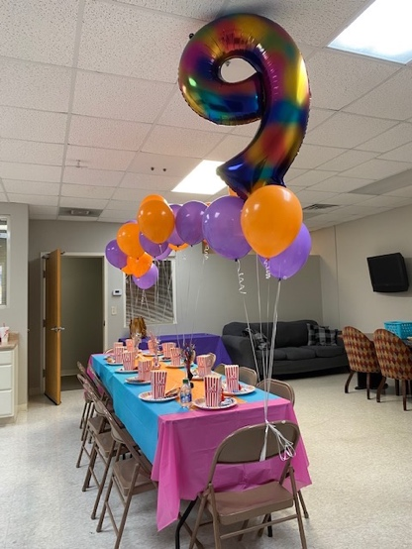

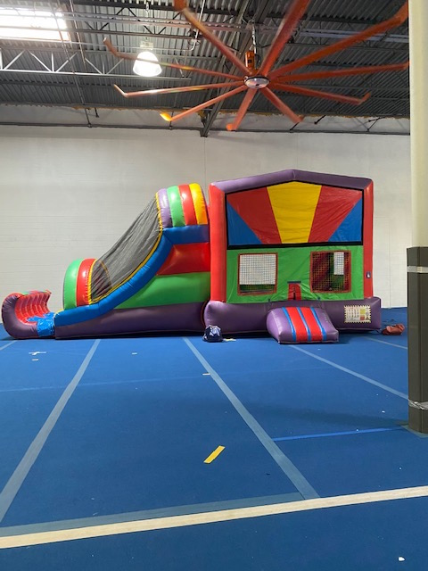

FAQ

Q: How many party participants are allowed?
A: Totally up to you but we find 1-15 guests is the perfect balance of fun and attention. However, we can accommodate more participants when registering.

Q: Are parents allowed to participate?
A: Unfortunately, only children ages 3 – 18 are allowed to participate in activities in the gym. Parents are welcomed and encouraged to watch, take pics and cheer!

Q: Do packages include food?
A: No, but we have optional add-on choices which include pizza.

Q: Does my child need to be a cheerleader or a member of Rockstar to have a party?
A: NO! All are welcome. Games and activities are scaled for experience levels.

Q: Will my party include a bounce house?
A: Yes, all packages include one bounce house.

Q: Can you take special requests?
A: Yes, with the right amount of notification we can accommodate most any request including instructor, games, music, theme, etc.

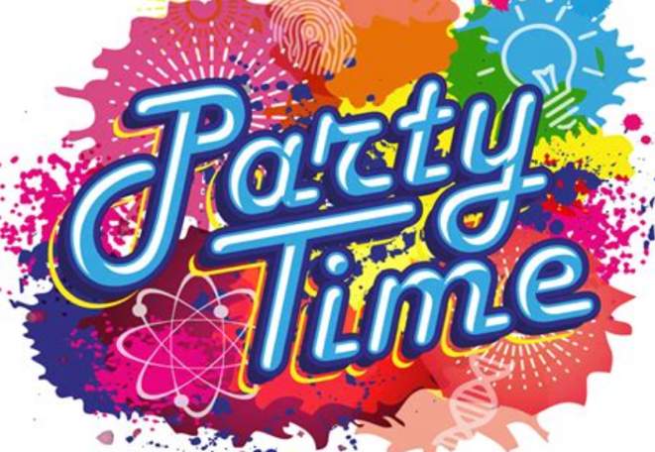

100 Londonderry Court, Suite 112
Woodstock, GA 30188
(770) 575-2259
info@rockstarcheeratlanta.com
www.rockstarcheeratlanta.com

BIRTHDAY PARTIES @

FUN
INFLATABLE
TRAMPOLINE
GAMES
MUSIC

